

POSITIVE PATHWAYS ROADSHOWS

Do you have a disability or health issue? Do you want to find a job?

Fife Council’s Supported Employment Service delivers the Positive Pathways programme. This helps people with disabilities, health problems, mental health issues and disabling conditions to find and keep a job of 8 hours or more. If you are struggling to keep your current job due to a disability or health condition our retention service can help you.

We are holding sessions across Fife, where you can speak with experienced staff about the support we provide and your options to find and keep a job.

**We will speak to employers on your behalf about:**

* Vacancies or work opportunities
* Support we can provide for you and your employer in the workplace

When you get a job, we will offer you and your employer support and guidance that will help you stay in work.

Our staff will be available from 10am till 2pm at:-

Inverkeithing Inverkeithing Civic Centre Thursday 19th September 2019

Cowdenbeath Brunton House Thursday 3rd October 2019

Dunfermline Kingsgate Shopping Centre Thursday 17th October 2019

Glenrothes Kingdom Shopping Centre Thursday 24th October 2019

Leven The Centre Leven Thursday 31st October 2019

Kirkcaldy Kirkcaldy Town House Thursday 7th November 2019

Cupar Cupar County Buildings Thursday 14th November 2019

No requirement to make an appointment, just arrive on the day.

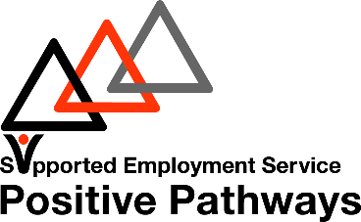

Contact us:

sw.ses@fife.gov.uk

03451 55 55 55 ext 444815